**ATAR PE Studies - Exercise Physiology Task 3 - Validation**

Name: ______________________

Score 37 %

Part A – Multiple Choice – circle the letter corresponding to your desired answer.

Questions 1 to 4 refer to the table below.

|  |  |  |
| --- | --- | --- |
| **Event duration** | **Energy Pathway** | **Fuel Source** |
| 1–4 seconds | Anaerobic | ? |
| 45–120 seconds | Anaerobic | ? |
| 5–10 minutes | ? | Muscle glycogen |
| 30 minutes | Aerobic | ? |

1. The main fuel source of ATP for 1–4 seconds of high intensity activity is ___________?
   1. muscle glycogen
   2. creatine phosphate
   3. fats
   4. ATP – CP
2. The main fuel source of ATP for 45–120 seconds of high intensity activity is ___________?
   1. muscle glycogen
   2. creatine phsphate
   3. fats
   4. ATP – CP
3. For an event that lasts between 5–10 minutes, the main energy pathway used will be ___________?
   1. protein
   2. anaerobic
   3. carbohydrates
   4. aerobic
4. The main fuel source of ATP for 30 minutes of sub-maximal, low intensity activity is ___________?
   1. muscle glycogen
   2. creatine
   3. fats
   4. ATP – CP
5. Which of the following order of words completes the statement correctly?

Blood flow to the digestive system is at rest than when exercising and

blood flow to the muscular system is at rest than when exercising.

* 1. greater, greater
  2. lower, lower
  3. lower, greater
  4. greater, lower

1. Which component of fitness **best** matches the definition below?

‘The ability to maintain the body’s equilibrium while in motion’

* 1. coordination
  2. static balance
  3. dynamic balance
  4. flexibility

1. Which of the following components of fitness is **least** important to the shot putter pictured below when executing the skill?

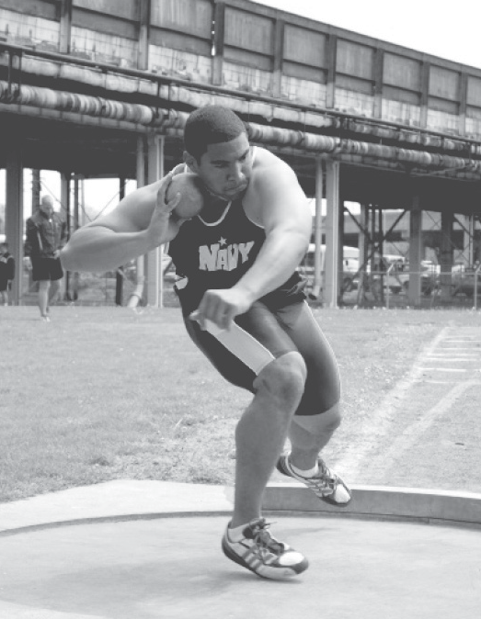

* 1. muscular strength
  2. balance
  3. reaction time
  4. power

1. Which of the following is an adaptation in the respiratory system that occurs as a consequence of regular participation in physical activity?
   1. a decrease in resting heart rate
   2. an increase in aerobic capacity
   3. a decrease in cardiac output
   4. an increase in ventilation during maximal exercise
2. To facilitate the long-term development of muscular endurance, which is the **most** relevant training type and training principle?
   1. continuous and duration
   2. cardiorespiratory endurance and frequency
   3. flexibility and intensity
   4. fartlek and reversibility
3. After a three month training program which included a significant amount of fartlek training, which of the following would not be experienced as a long term adaptation?
   1. Muscle hypertrophy
   2. Increased blood volume
   3. Increased capillarisation
   4. Increased heart rate

**Part B - Short Answer – Write answers to all questions in the space provided**

Question 11 (4 marks)

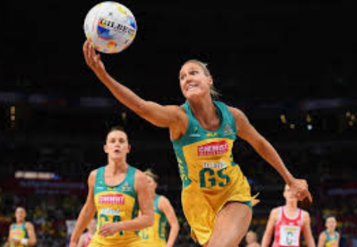

Caitlin Bassett is a member of the West Coast Fever Netball team. Agility and flexibility are important fitness components for Cailtin. Define these components and name a type of training that would improve each fitness component.

________________________________________________________________________________________

________________________________________________________________________________________

________________________________________________________________________________________

________________________________________________________________________________________

________________________________________________________________________________________

________________________________________________________________________________________

________________________________________________________________________________________

Question 12 (8 marks)

In 2011, Australian Craig Alexander won his third Hawaiian Ironman in the record time of 8 hours, 3 minutes and 56 seconds. The race requires athletes to swim 3.8km, cycle 180km and run a marathon (42km).

a). Identify and briefly outline the six principles of training critical for continued success in this Ironman event.

________________________________________________________________________________________

________________________________________________________________________________________

________________________________________________________________________________________

________________________________________________________________________________________

________________________________________________________________________________________

________________________________________________________________________________________

________________________________________________________________________________________

________________________________________________________________________________________

________________________________________________________________________________________

b). What is meant by the term ‘diminishing returns’ and explain how it relates to Craig’s training and performance.

________________________________________________________________________________________

________________________________________________________________________________________

________________________________________________________________________________________

________________________________________________________________________________________

Question 13 (4 marks)

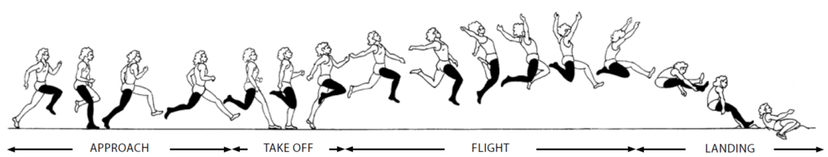

Explain which four components of fitness are important for success in long jumping.

________________________________________________________________________________________

________________________________________________________________________________________

________________________________________________________________________________________

________________________________________________________________________________________

________________________________________________________________________________________

________________________________________________________________________________________

________________________________________________________________________________________

________________________________________________________________________________________

Question 14 (6 marks)

Melinda wants to compete is a 5km fun run in two months. Define the three most relevant training types she would need to include in her training program in preparation for this event. For each type of training, explain, using a specific example, how Melinda would have applied progressive overload in her training program.

________________________________________________________________________________________

________________________________________________________________________________________

________________________________________________________________________________________

________________________________________________________________________________________

________________________________________________________________________________________

________________________________________________________________________________________

________________________________________________________________________________________

________________________________________________________________________________________

Question 15 (5 marks)

There are a number of ways in which resistance training can be used. By manipulating the load (weight), repetitions and number of sets, different fitness components can be enhanced. Complete the table below which summarises the manipulation of these variables.

|  |  |  |  |  |
| --- | --- | --- | --- | --- |
| **Component** | **Load (%1RM)** | **Repetitions** | **Sets** | **Speed of lift** |
| Muscular strength | _____________ | 1 – 10 | 3 – 5 | _____________ |
| _____________ | 30% - 60% | 10 – 12 | 2 – 3 | _____________ |
| _____________ | 40% - 60% | 15 - 25 | 2 - 3 | Medium |

**End of Questions**

**Task 3 Validation Answer key**

1. The main fuel source of ATP for 1–4 seconds of high intensity activity is ___________?
   1. muscle glycogen
   2. creatine phosphate
   3. fats
   4. ATP – CP
2. The main fuel source of ATP for 45–120 seconds of high intensity activity is ___________?
   1. muscle glycogen
   2. creatine phosphate
   3. fats
   4. ATP – CP
3. For an event that lasts between 5–10 minutes, the main energy pathway used will be ___________?
   1. protein
   2. anaerobic
   3. carbohydrates
   4. aerobic
4. The main fuel source of ATP for 30 minutes of sub-maximal, low intensity activity is ___________?
   1. muscle glycogen
   2. creatine phosphate
   3. fats
   4. ATP – CP
5. Which of the following order of words completes the statement correctly?

Blood flow to the digestive system is at rest than when exercising and

blood flow to the muscular system is at rest than when exercising.

* 1. greater, greater
  2. lower, lower
  3. lower, greater
  4. greater, lower

1. Which component of fitness **best** matches the definition below?

‘The ability to maintain the body’s equilibrium while in motion.’

* 1. coordination
  2. static balance
  3. dynamic balance
  4. flexibility

1. Which of the following components of fitness is **least** important to the shot putter pictured below when executing the skill?
   1. muscular strength
   2. balance
   3. reaction time
   4. power
2. Which of the following is an adaptation in the respiratory system that occurs as a consequence of regular participation in physical activity?
   1. a decrease in resting heart rate
   2. an increase in aerobic capacity
   3. a decrease in cardiac output
   4. an increase in ventilation during maximal exercise
3. To facilitate the long-term development of muscular endurance, which is the **most** relevant training type and training principle?
   1. continuous and duration
   2. cardiorespiratory endurance and frequency
   3. flexibility and intensity
   4. fartlek and reversibility
4. After a three month training program which included a significant amount of fartlek training, which of the following would not be experienced as a long term adaptation?
   1. Muscle hypertrophy
   2. Increased blood volume
   3. Increased capillarisation
   4. Increased heart rate

Question 11 (4 marks)

Caitlin Bassett is a member of the West Coast Fever Netball team. Agility and flexibility are important fitness components for Cailtin. Define these components and name a type of training that would improve each fitness component.

|  |  |
| --- | --- |
| **Description** | **Marks** |
| **Agility** – change position of the body quickly and efficiently while maintain balance | 1 |
| Associated training type – interval training or circuit training | 1 |
| **Flexibility** – capacity of a joint/s to move through a full range of motion without injury | 1 |
| Associated training type – static stretching or dynamic stretching | 1 |

Question 12 (8 marks)

In 2011, Australian Craig Alexander won his third Hawaiian Ironman in the record time of 8 hours, 3 minutes and 56 seconds. The race requires athletes to swim 3.8km, cycle 180km and run a marathon (42km).

a). Identify and briefly outline the six principles of training critical for continued success in this Ironman event.

|  |  |
| --- | --- |
| **Description** | **Marks** |
| **Specificity** – different forms of training produce different effects – you get what you train for | 1 |
| Progressive overload – a gradual increase in the load placed upon the athlete to induce adaptations | 1 |
| Intensity – how hard a person must work during a training session (usually measured using heart rate) | 1 |
| Duration – the length of the training session. This relates directly to the intensity of the session | 1 |
| Frequency – how often the person needs to train to see gains in fitness (3 – 5 sessions are recommended) | 1 |
| Reversibility – if exercise stops, not done frequently enough or not to a sufficient intensity, then gains are lost | 1 |

b). What is meant by the term ‘diminishing returns’ and explain how it relates to Craig’s training and performance.

|  |  |
| --- | --- |
| **Description** | **Marks** |
| **Diminishing returns** – the higher the level of fitness, the harder it is for the athlete to make significant improvements despite continued progressive overload in training programs because improvement is not infinite | 1 |
| Craig will have to continue to train very hard to see only minor improvements in results for each segment of the race | 1 |

Question 13 (4 marks)

Explain which four components of fitness are important for success in long jumping.

|  |  |
| --- | --- |
| **Description** | **Marks** |
| **Any 4 of the following explained;**  Speed – for the run-up. More speed on the run-up would increase the distance of the jump  Power – for take-off. Allows for an explosive force off the board  Balance – Flight and landing. Maintains stability in the air and on impact  Flexibility – all for the full extension at joints and increased range of movement or reach or helps the athlete avoid injuring the muscle, connective tissue and joints while competing  Strength – allows the athlete to control and change the direction of the athlete’s centre of mass  Body composition – proportion of bone fat and muscle – leaner body will allow greater acceleration  Coordination – getting the foot into the right position on the board and then body position through the air  **Do not** accept Cardio endurance, Muscular endurance, agility or reaction time | Up to 4 marks |

Question 14 (6 marks)

Melinda wants to compete is a 5km fun run in two months. Define the three most relevant training types she would need to include in her training program in preparation for this event. For each type of training, explain, using a specific example, how Melinda would have applied progressive overload in her training program.

|  |  |
| --- | --- |
| **Description** | **Marks** |
| Any 3 of the following acceptable training types – (need adequate definition)  Continuous training – going for long distance or timed runs at a low intensity  Fartlek training – speed play, continually altering speed at various intervals  Interval training – short bouts of high intensity exercise with rest periods in between  Resistance training – light weight and high reps aiming to increase muscle endurance | 1  1  1  1 |
| Application of progressive overload for each method;  Continuous training – increase the time or distance by 10% each week  Fartlek training – increase length of sprints, overall pace of run, decrease time doing lower intensity running  Interval training – increase the time or distance of the interval, decrease the rest ratio  Resistance training – increase the number of reps, number of sets – don’t want to add bulk – not helpful for running | 1  1  1  1 |

Question 15 (5 marks)

There are a number of ways in which resistance training can be used. By manipulating the load (weight), repetitions and number of sets, different fitness components can be enhanced. Complete the table below which summarises the manipulation of these variables.

|  |  |  |  |  |
| --- | --- | --- | --- | --- |
| **Component** | **Load (%1RM)** | **Repetitions** | **Sets** | **Speed of lift** |
| Muscular strength | 75% - 100% | 1 – 10 | 3 – 5 | Slow/controlled |
| Muscular Power | 30% - 60% | 10 – 12 | 2 – 3 | Fast |
| Muscular Endurance | 40% - 60% | 15 - 25 | 2 - 3 | Medium |